Tasks

1.Pick a recent music concert, cricket match, or college fest you attended or heard about, and list 5 offline event marketing tactics (like posters, flyers, street teams, branded merchandise, etc.) you noticed or think were used to promote it.

2.Design a creative event flyer for a launch party of a new food outlet in your city, targeting college students — include key elements like event name, date, venue, call-to-action, and one catchy slogan.<br><br><em><strong>Hint:</strong> Use Canva or any free online flyer maker for your design.</em>

3.Imagine you are promoting a pop-up sneaker sale (like a limited edition drop, inspired by Myntra or Flipkart sales) in your college. Write a step-by-step offline marketing plan covering at least 3 channels (e.g., campus posters, influencer invites, street teams, branded props).

4.Interview 3 friends or classmates about which offline event promotions caught their attention recently (e.g., IPL fan zones, Zomato food festivals, movie roadshows). Summarize their answers and identify one common element that made those promotions effective.

Answer:-

1. Offline event marketing tactics
Event chosen: Zomaland-style Food and Music Festival / College Fest
Location: [Your City Name]
Date: [Event date]
Zomaland ek food-and-entertainment carnival format hai jahan food stalls, music, DJs/comedians aur carnival games ko ek hi event space mein combine kiya gaya hai. Aise events mein food experience ke saath interactive activities aur live entertainment audience ko attract karte hain.thenewsminute+1

5 offline marketing tactics
- Campus posters and banners
College gates, canteen, library noticeboard aur hostel areas mein colourful posters lagaye jaate hain. Poster par celebrity performer, date, venue aur ticket price large letters mein likha hota hai.
- Flyer distribution
Event volunteers high-footfall spots—cafés, coaching centres, metro exits aur college gates—par flyers distribute karte hain. Flyer mein QR code, early-bird ticket offer aur event highlights mention hote hain.
- Street team promotion
Branded T-shirts pehne volunteers college campus ya market area mein students se directly baat karte hain. Woh event ke baare mein batate hain aur instant registration/ticketing ke liye QR code scan karwate hain.
- Branded merchandise
Event-themed wristbands, caps, tote bags, badges aur stickers distribute/sell kiye jaate hain. Jab students in products ko carry karte hain, toh event ki visibility aur excitement naturally spread hoti hai.
- Interactive photo booth / installation
A large neon sign, food-themed prop ya selfie booth mall/campus mein lagaya ja sakta hai. Students photo click karke social media par share karte hain, aur passer-by ko event ke baare mein curiosity hoti hai.
College events ke liye posters, banners, street art, flash mobs, campus ambassadors aur inter-college roadshows offline buzz create karne ke useful methods hote hain.eventland+1

2. New food-outlet launch flyer
Food outlet name: BiteStreet Café
Launch party name: The Big Bite Bash
Venue: BiteStreet Café, [Your City / College Area]
Date: Saturday, [Date]
Time: 5:00 PM onwards

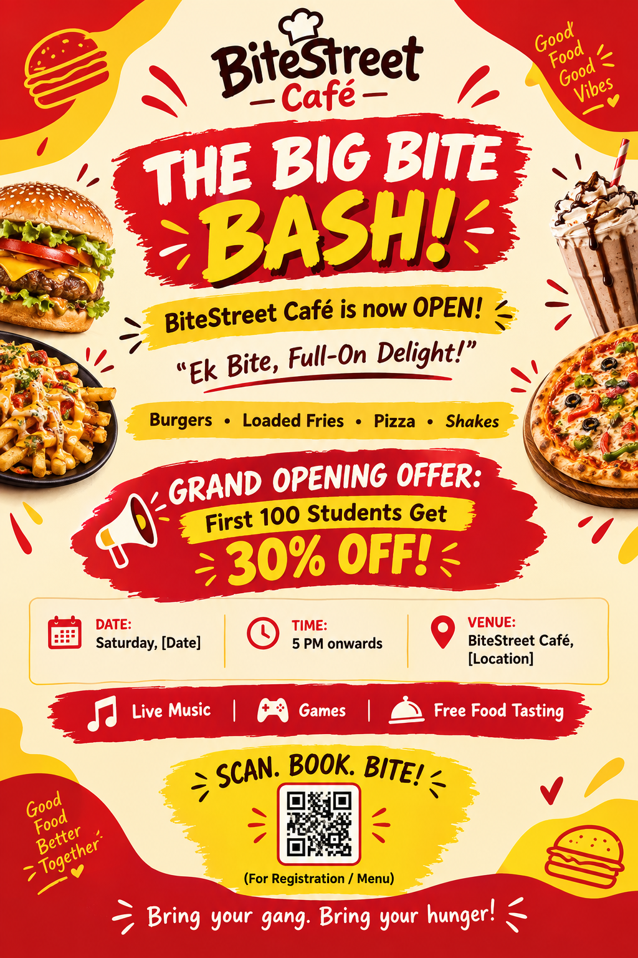

Flyer design idea
- Top mein large burger/fries visual aur bold title: “The Big Bite Bash!”
- Background red, yellow aur cream use karo, kyunki yeh colours food category mein energetic aur attractive feel create karte hain.
- “30% OFF” ko yellow sticker/starburst mein rakho.
- Bottom par QR code aur CTA: “Scan. Book. Bite!”
- Canteen, hostel noticeboard, college gate aur nearby cafés mein flyer paste/distribute karo.

3. Pop-up sneaker sale offline plan
Event name: KICKDROP: Campus Sneaker Pop-Up Sale
Concept: Myntra/Flipkart limited-edition sale jaisa excitement—limited stock, exclusive discount aur photo-friendly sneaker experience.

Step-by-step plan
- Campus posters and standees
Event se 10–12 din pehle college gate, library, canteen, sports ground aur hostel noticeboard par posters lagayenge. Headline hoga: “KICKDROP Is Coming—Limited Pairs. Limited Time.”
- Teaser props and sneaker display
Canteen ya central courtyard mein ek locked transparent sneaker box rakhenge, jisme ek limited-edition shoe visible hoga. Box par countdown sign hoga: “Unlocking on [Date].”
- Student influencer invites
College ke fashion, dance, sports aur content-creator students ko early-access invite denge. Unhe event se pehle sneaker try-on session aur preview photos ka chance milega.
- Campus street team
Branded T-shirts pehne 4–5 volunteers lunch break aur class-ending time par flyers distribute karenge. Unke paas QR code hoga jisse students sale ke liye pre-register kar sakte hain.
- Branded photo zone
Pop-up venue par “Step Into The Drop” neon backdrop, full-length mirror aur props setup honge. Student sneaker try karke photo/reel bana sakta hai.
- Limited-time offers
First 50 buyers ke liye 20% discount, “Buy sneakers + socks, get 10% off” combo aur lucky-draw coupon rakhenge. Limited stock board urgency create karega.
- On-ground contest and follow-up
Students photo post karke #KICKDROPCollege use karenge aur store account tag karenge. Best outfit photo ko sneaker voucher milega. Event ke baad QR registrations ko thank-you coupon send kiya jayega.
Campus posters, ambassador-style peer promotion, high-footfall placement aur QR-based interaction students tak direct reach ke practical ways hain.

4. Friends’ interview summary
Note: Neeche sample responses diye gaye hain. Final assignment mein aap apne 3 friends ke actual opinions aur names add kar sakte ho.
Friend | Offline promotion noticed | What caught their attention?
Friend 1: Aarav | IPL fan zone at a mall | Giant team-jersey display, cricket-game activity aur photo booth. Usne kaha ki interactive game dekhkar woh ruk gaya.
Friend 2: Mehak | Zomato food festival / food-event stall | Bright red branding, food smell, live music aur multiple restaurant stalls. Usko event ka festive atmosphere attractive laga.
Friend 3: Danish | New movie roadshow at a mall | Life-size character cut-outs, photo props aur free merchandise. Usne photo ke liye participate kiya aur movie ke baare mein interest develop hua.

Common element
Teenon friends ke answers mein ek common point tha: interactive visual experience. Sirf poster ya banner se zyada, games, giant props, photo booths, live music aur free merchandise ne unka attention grab kiya. Jab audience ko kuch karne, photo lene, taste karne ya reward jeetne ka chance milta hai, toh promotion memorable ban jata hai aur event attend karne ki curiosity badh jaati hai.
Zomaland ke format mein top restaurants, entertainment, games aur interactive installations ek hi place par hote hain; isi type ka experience-based design event ko simple food promotion se zyada engaging bana deta hai.

